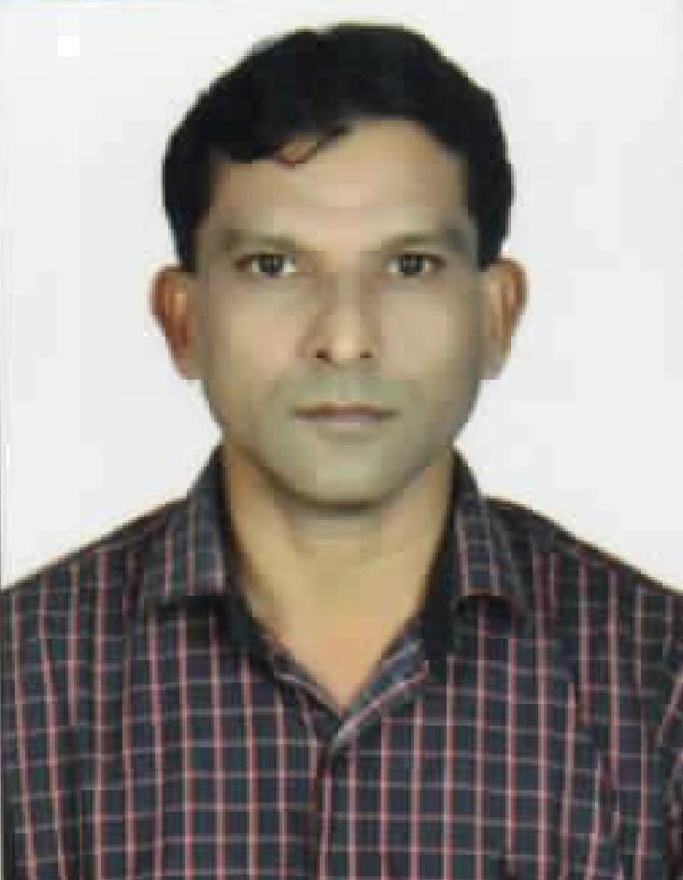

PRAMODKUMAR M. PATEL

Mobile No. : +91 9727986918 / +91 7567958986
Email ID: pramod270@yahoo.com

PIPE FITTER / PIPE FABRICATOR AND STRUCTURE

- Seeking challenging assignment in the domain of maintenance, fabrication and erection

PROFILE

- Passed S.S.C. Board Examination.
- A competent and I.T.I with 22 years of rich experience in Fabrication and Erection area.
- Familiar with PIPING AND STEEL STRUCTURAL Inspection.
- Capable of handling the construction, erection, fabrication and maintenance activities as specified in the drawings.
- Total experience of 22 YEARS in New Fabrication, Maintenance, Manufacturing Project and Offshore work.
- Possess expertise across assembly, installation, erection of structural & piping in maintenance new and Manufacturing Projects.
- Efficient communicator with strong negotiation, problem resolution & client need assessment aptitude.

KNOWLEDGE PREVIEW

- Familiar with drawings like P&I diagrams, isometric drawing CAD, Structural drawings.
- Familiar with international standards like ASME, API, AWS.
- Testing – Pressure test.
- Familiar with ISO 9001:2008 standard.
- Knowledge in ASME, API, ASW

CERTIFICATION

- ITI PASSED IN JULY 1988.
- BOSIET – BASIC OFFSHORE SAFETY INDUCTION & EMERGENCY TRAINING.
- HSE INDUCTIO TRAINING
- H2S INDUCTION TRAINING
- FIRST AID COURSE
- TRADE Test Certificates

PROJECT UNDERTAKEN: OFFSHORE EXPERIENCE: 12 YEAR

- Client : MEGI EQUATORIAL GUINEA WEST AFRICA
Company: Fluor Industrial Services
Designation: Fitter
Duration: 28/10/2021 to 06/12/2021
Job Detail: Major offshore maintenance work

- Client : MEGI EQUATORIAL GUINEA WEST AFRICA
Company: Fluor Industrial Services
Designation: Fitter
Duration: 17/10/2019 to 20/02/2020
Job Detail: Major offshore maintenance work

- Client : QATAR PETROLIUM NORTH OIL COMPANY OFFSHORE
Company: Team Energy Resources Middle East LLC
Designation: Fabricator
Duration: 01/08/2018 to 30/09/2019
Job Detail: Major offshore shutdown work

- Client : RELIANCE INDUSTRIES LTD HAZIRA SURAT GUJARAT INDIA
Company: Vishal Enterprise
Designation: Pipe Fabricator
Duration: 05/11/2016 to 07/10/2017
Job detail: Fabrication and install pipeline work

- Client : CHEVRON CABINDA GULF OIL COMPANY ANGOLA
Company: GPS Saipem Petromar
Designation: Pipe Fitter
Duration: 30/06/2011 to 13/07/2016
Job detail: Offshore & onshore DECK and JACKET pipeline fabrication & erection, mejor maintenanace shutdown works

- Client : BAPCO BAHRAIN , DOLPHINE QATAR
Company: Shaw Nass Middle East W.L.L – Bahrain
Designation: Pipe Fabricator / Fitter
Duration: 17/09/2007 to 28/07/2010
Job detail: Pra fabrication pipes spool as per isometric drawing, pipe size “1 to 42”

- Client : TOTAL , CHEVRON
Company: Acergy Group, Benguela – Angola
Designation: Pipe Fitter
Duration: 27/01/2006 to 11/12/2006
Job detail: Major construction of barge plate forms for OFFSHORE job

- Client : KNPC &KUWAIT OIL COMPANY
Company: Al - Meer Technical Services – Kuwait
Designation: Pipe Fitter, Maintanance Fitter
Duration: 11/03/2004 to 25/10/2005
Job detail: Fabrication pipe spool and major shutdown

- Client : ARAMCO SASREF, SAMAD SAFCO SHUTDOWN JOBS SAUDI ARABIA
Company: Olyan Descon Company Soudi Arabia
Designation: Pipe Fitter / Fabricator
Duration: 27/12/2002 to 05/10/2003
Job detail: Fabricating, pipe fitting with elbow, flange, tees, reducers, valves, repair of pipeline, RE-install pipeline, bolting and major maintenance shutdown

- Client : KNPC & KUWAIT OIL COMPANY
Company: Al - Essa & Company Kuwait
Designation: Pipe Fitter /Fabricator
Duration: 17/08/1996 to 26/03/2000
Job detail: Fabrication of pipeline 1”to24” as per isometric drawing, pipefittings of M.S, C.S, S.S, G.I & SCH of pipe 20, 40, 80 & 160

- Client : KNPC & KUWAIT OIL COMPANY
Company: Osmo Anlagebau GMBH & Company K,G - Kuwait
Designation: Pipe Fitter / Fabricator
Duration: 15/10/1998 to 22/12/1999
Job detail: Fabrication of pipeline & pipe fittings, installation of new pipeline & hydro testing

- Client : MINA ABDULLA REFINERY KUWAIT
Company: Spic - Smo Kuwait
Designation: Plant Mechanic
Duration: 26/05/1994 to 11/11/1995
Job detail: Replacement of old pipe pipeline & install new pipeline of gas, steam & hydrotesting. Maintanance work of exchanger, tower, vessels, boiler & also installation and checking of safety valves, control valves & check valves.

PERSONAL DETAILS

- Name : Patel Pramodkumar Maganlal
- Passport No. : M 2863954
- Place of Issue : Surat
- Date of Issue : 14/10/2014
- Date of Expiry : 13/10/2024
- Sex : Male
- Marital Status : Married
- Nationality : Indian
- Date of Birth : 31/12/1969
- Permanent Address : At & Post : Dipla ( Punjhouse) Via: Marolibazar
Ta. : Jalapore Dist.: Navsari Pin. : 396436
Gujarat, India.
- Languages Known : English, Gujarati, Hindi
- Contact No. : +91 9727986918 / +91 7567958986

DECLARATION

I hereby declare that all the information given above are true and correct with the best of my knowledge and i bear the responsibility of the above – mentioned particulars.

I hope that you will consider m application favorably & call me for a personal interview. I shall produce my all the testimonials, Certificates in original.

Please consider my application and give me opportunity for an interview.

Thanking You,

Your faithfully, Pramodkumar Patel

