CURRICULUM VITAE
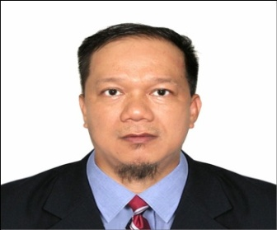
OBJECTIVE : To pursue a challenging career in practical life and gain more experience, to work and apply all that I have learned from academics and experience and to be part of a dynamic team.

Position : Electrical & Instrumentation Engineer
Name : Jessie Erosa Valenzuela
Height : 5’ 4’’
Weight : 143 lbs.
City Address : Apalit, Pampanga
Provincial Address : Barangay Tabuyoc, Apalit, Pampanga
Date & Place of Birth : December 28, 1973
Sumabnit East, Binalonan, Pangasinan
Sex : Male
Civil Status : Married
Religion : Christian
Citizenship : Filipino
Mobile Number : +639176686024 / +639454624838
E – Mail Address : valenzuelajessieerosa@gmail.com
Name of Wife : Priscilla Manlapaz Valenzuela
Name of Children : RyuManlapaz Valenzuela (15 years old)
: Bryant Dale Manlapaz Valenzuela (12 years old)
Language/Dialect you can Speak or Write: English and Tagalog
Person to be Contact in case of Emergency
Name : Priscilla Manlapaz Valenzuela (Wife)
Mobile Number : +639176686024 (Philippines)
Character Reference: Engr.Mervin H.B Laurente – MEP Team Leader – ITCC Project-Riyadh,KSA
Engr. Nelson G. Martinez – IIEE President Riyadh 2012 – 2017 +966509258739 – Riyadh, Kingdom of Saudi Arabia

EDUCATIONAL ATTAINMENT
Elementary School : Sumabnit Elementary School 1980 – 1986
High School : Sumabnit National High School 1986 – 1990
College : Pangasinan State University 1990 - 1995
Course : Bachelor of Science in Electrical Engineering

Special Skills: Working knowledge at work drawings and on Site – Supervision. Can work in an environment that will give an opportunity to excel and advance in my career. Building client relationship. Travel as required to ensure the successful execution of project and /or department goals. Activity participation in mentally self-improvement learning technical situation. Testing and commissioning experience in a variety of site condition. Leadership & team building experience. Excellent communication skills with high experience in English (with verbal & written).Knowledge in NEC, UL, ASHRAE, SASO, IEEC, NFPA & other Electrical Codes
Total Experience : 27 years & 7 mos.
Local experience = 10 years
Middle East exp. = 14 years
Guam, USA = 3 years & 7 mos.

WORK PROFESSIONAL EXPERIENCE:

September 20, 2017 up to April 23, 2021:
Electrical Engineer – Black Construction Company
Project : NDWWTP – Northern District Waste Water Treatment Plant, Dededo GUAM, USA

June 11, 2011 up to May 01, 2017 :
Senior Electrical Engineer – DAR AL RIYADH CONSULTANT
Project: ITCC – INFORMATION TECHNOLOGY & COMMUNICATION COMPLEX Imam Saud Road, Riyadh, Kingdom of Saudi Arabia

June24, 2006 up to April 30, 2011
QA/QC Electrical Engineer - SBG –RPD/Saudi Bin Laden Group of Company
Project : Saudi Aramco Oil & Gas (FGP) – Fadhili Gas Plant
Jubail, Kingdom of Saudi Arabia

April 27, 2004 up to May 06, 2006
Electrical Engineer - Romago Incorporated Electrical .Mechanical.Engineers. Contractor
Project : Heritage Park Hotel, TaguigCity , Philippines
(Finished Contract Project)

February 01, 2000 up to March 04, 2004

Electrical Engineer - Ciper Engineering CorporationElectrical Engineers. Contractors
Project: Astoria Plaza Condominium , One San Miguel Ave. Pasig City, Philippines.
(Finished Contract Project)
November 10, 1998 up to December 12, 2000
Electrical Engineer -Rosehills Management Philippines
Project : LMO Building , Heritage Park, Fort Bonifacio, Taguig City, Philippines
(Finished Contract Project)
September 08, 1996 up to September 30, 1998
QA/QC Electrical Engineer - Pacific Mediterranean Const. Co. Engineers. Contractors
Project : Burj Al Arab Building , United Arab Emirates, Dubai
(Finished Contract Project)

Project: NDWWTP – Northern District Waste Water Treatment Plant
Dededo GUAM, USA
- Design of Power Transformer & Distribution Panel’s Facilities for wastewater pumping & treatment plant project.
- Will design and program various PLC Controllers for support of wastewater project facilities.
- Functions as Project Engineer on medium to large projects, assuming responsibility for the work of the group.
- May plan, direct & supervised the work of major engineering unit or project requiring a large-scale expenditure of manpower and financial investment.
- Leads other Engineers & design personnel in technical excellence and growth in the quality improvement process.
- Provides technical consultations for interdisciplinary analytical studies and analyses.
- Ensures compliance of design with all applicable codes & regulations, providing the seal of Professional Electrical Engineer when required by the statute or contract.
- Prepares material / equipment specifications and purchase requisitions, reviews supplier data, witnesses shop test, assist with assessing supplier manufacturing capabilities.
- Develops operations & maintenance plans, develops standard operating procedures, prepares O&M manuals, and may conduct on-site training of personnel.
- Conduct surveys, studies and site investigations.
- Perform RAM - reliability, availability, maintainability & safety analyses.
- Maintains affiliation with professional societies to keep abreast of current technologies.
- Helps determine budget estimates and staffing requirements for the defined scope & schedule. May assist in other administrative and technical duties.
- Recommends and prepares technical papers.
- Performs other responsibilities associated with this position as may be appropriate with as follows,
- Monitor materials used in site installation as per SPECS and Consultants approval.
- Prepares Shop Drawings for approval as well as for site used including PMR–Project Manager Report.
- Inventory of incoming equipment materials which are ordered and prepared to deliver on site projects like Genset, MDB’s, Distribution Panels, Transformers, MVSG – Medium Voltage Swithgear others.
- Attend General & Technical meeting for the project.

Project: ITCC – Information Technology & Communication Complex

- Monitor & Supervised FIR –Field Inspection Request for roughing – installations of conduits, fittings & boxes for Low Voltage & Low Current System (From 5th Basement up to 22thFlr.& RGL – Roof Garden Level) including Bare Copper Wire & Bare Copper tape for Lightning Protection System
- Monitor & Supervised FIR – Field Inspection Request for wiring & cable installations for Low Voltage & Low Current Systems ( From 4th Basement to 22th Floor ).
- Monitor & Supervised FIR – Filed Inspection Request for wiring - continuity &meggering test for Low Voltage & Low Current Systems ( From 5th Basement up to 22th Floor level)
- Monitor & Supervised FIR – Field Inspection Request for the installation of cable trunking for Low Voltage & Low Current System.
- Monitor & Supervised FIR – Field Inspection Request for the Installation of Cable Tray for Low Voltage System.
- Monitor & Supervised FIR – Field Inspection Request for the installations of MVSG Panels including MDB’s, DP’s & MCCB’s.
- Monitor & Supervised FIR – Field Inspection Request for the installations of GCP, ATS & Gen set 1 & 2 for the Fire Pump Supply in Basement #5.
- Monitor & Supervised FIR – Field Inspection Request for the wiring of Homerun circuit for (normal & emergency) including megger test and continuity test for each Panel Schedule in the Electrical room (Part 1 & 2).
- Monitor & Supervised FIR – Field Inspection Request for the installation of boxes & wiring @ Block wall for Normal Lighting switches including Wall lights & Exit lights.
- Monitor & Supervised FIR – Field Inspection Request for the installation of boxes & wiring @ Block wall for Power Socket and Power FCU’s of Thermostat switches.
- Monitor & Supervised FIR – Field Inspection Request for the installation of disconnect switch for FCU’s, 3 – 4mm2 RYB as per circuit indication (normal & emergency).
- Monitor & Supervised FIR – Field Inspection Request for MV Cables, 3x300mm 1C, 15KV/PVC/SCW in cable trench Main entry from SEC- Saudi Electric Corporation to MRMU- Master Ring Main Unit.
- Monitor & Supervised road lightings installations including PLC – Programmable Logic Controller for Traffic lights signals.
- Monitor & Supervised DDC – Direct Digital Controller installations for all Low current Panes, Fire Alarm, Public Address, CCTV, BMS, Access Card, Car Access entrance & exit, & other’s as per plan.
- Monitor & Supervised installations of 600 MW Solar Panels and each accessories like cables, charge controller, DC Batteries, Inverter, Service Main Breaker Panel which goes to loads / appliances.
- Review Drawings, Specifications & Method of Statements for executing in Site work project.
- Monitor & Supervised FIR – Field Inspection Report for Testing & Pre-Commissioning for Low Voltage & Low Current System.
- Attend start – up commissioning
- Monitor & Supervised Final-Testing and Commissioning & Fire Alarm Cause & Effect Matrix Integration for the whole system of Electrical.
- Attend meeting with Testing & commissioning including progress report meeting that support works accomplishment with regards to the project.
- Review AS-BUILT DRAWINGS & OMM SUBMITTALS
- Review TQ SUBMITTALS with regards to variation orders with the projects.
- Prepare Snaglist.

Project: Saudi Aramco Oil & Gas Plant
Fadhili Gas Plant. Jubail, Kingdom of Saudi Arabia
- Monitor, Supervised & shall provide for preventive, routine and non-routine maintenance and for the repair of the electrical equipment and machines and of the related control boards.
- Ensure that all reporting routines are followed and that all equipment related paperwork are carried out within area of responsibility, such as maintenance records, updating of service and instruction manuals, instructing procedures, etc.; 3) Reporting routines regarding the EDP – Electronic Data Processing based maintenance system on board.
- Monitor & Supervised of keeping stock of spare parts and consumables for the equipment of responsibility at the appropriate level by verifying the stock levels and reporting to Management Superiors the deficiencies taking in consideration future maintenance requirements and delivery time;
- Monitors & Supervised the reliability of spare parts utilized;
- Supervise the disassembly, loading, unloading and assembly of the power plant and electrical devices and equipment; 7) Familiarization with all classification society and authorities rules and regulations applicable to area of responsibility;
- Ensure that all orders and instructions by Management Superiors received verbally or in writing are fully understood and adhered to;
- Be safety conscious in all work and use compulsory protective equipment;
- Implement & ensure familiarization with all applicable work and safety procedures, and promote implementation of same;
- Implement & ensure that before any maintenance activity is started, a proper investigation is carried out, precautions have been taken the equipment have been properly isolated from the main switchboard, the circuit breakers are locked, warning signs are posted and the “work permit” has been signed;
- Instruct all personnel assigned to their duties and responsibilities and of any special safety precautions to be taken prior to start-up of any work;
- Implement & ensure that personnel working under supervision as well to carry life vests and safety lines when working in exposed area or in around the moonpool;
- Monitor all promptly report accidents, near-miss accidents, Non-Conformances and safety hazards to Management Superior;
- Monitor , Supervised & participate in safety meetings and safety drills held on board;
- Supervised & carry out duties according to the Emergency Preparedness Action Plan when needed;
- Monitor, Supervised, implement & ennsure good housekeeping in working areas;

Project: Heritage Park Hotel, Astoria Plaza Condominium & LMO Building
Project: Burj Al Arab United Arab Emirate, Dubai

- Monitor/Supervised – installation of all embedded Electrical materials @ roughing-ins for Low Voltage & Low Current.
- Monitor/Supervised wiring installations of Low Voltage & Low current wires & calbes including continuity and meggering test.
- Monitor/Supervised for the installations of Solar Panel including accessories, charge controller, batteries, inverters and to AC appliances load side.
- Monitor/Supervised installations of Low Voltage & Low Current fixtures & Panel’s.
- Prepare Snaglist
- Attend meeting & Testing and Commissioning

Seminars and Workshop:

- Basic Occupational Safety and Health Training
(CERTIFICATE)

- The 7th WORLDBEX Seminars (CERTIFICATE )
‘’ Exploring Advancement in Global Construction Network ‘’

- OSRAM Seminar Workshop & Product Orientation
(CERTIFICATE)

- GMS INSTITUTE OF TECHNOLOGY ( CERTITICATE )

ECO PANEL MDB’s INDUSTRIAL SITE PLANT VISIT - RIYADH, KSA
Industrial City II - Riyadh, Kingdom of Saudi Arabia
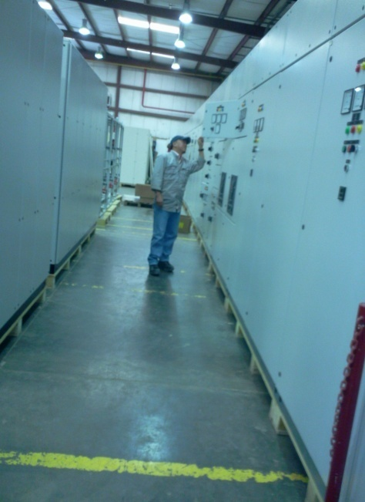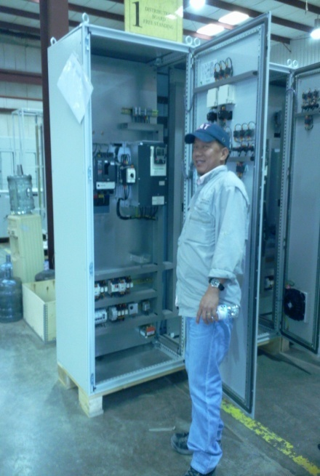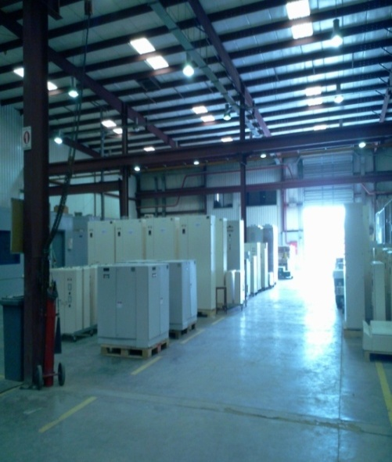

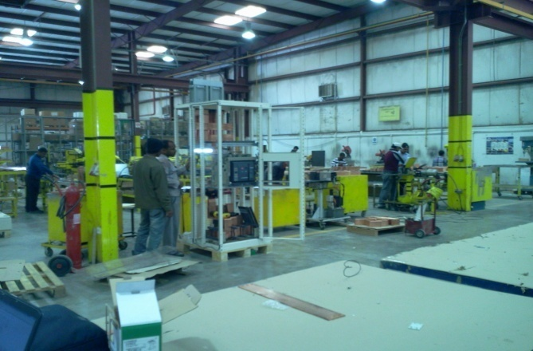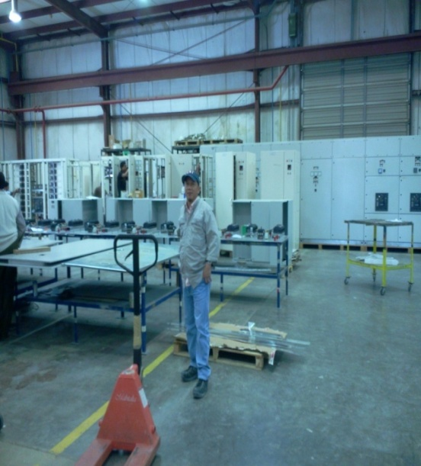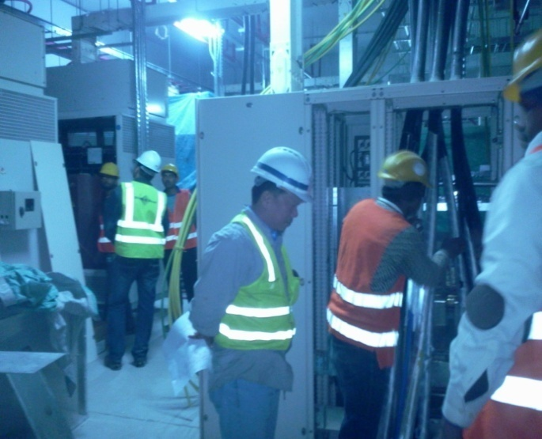

SCE – SAUDI COUNCIL of ENGINEER
Exit 5 Road - Riyadh, Kingdom of Saudi Arabia
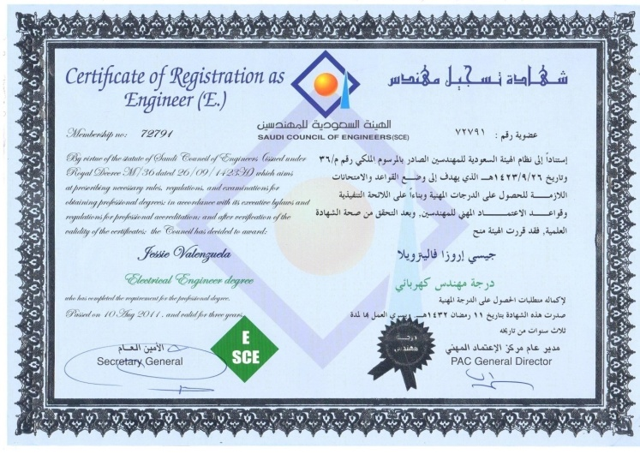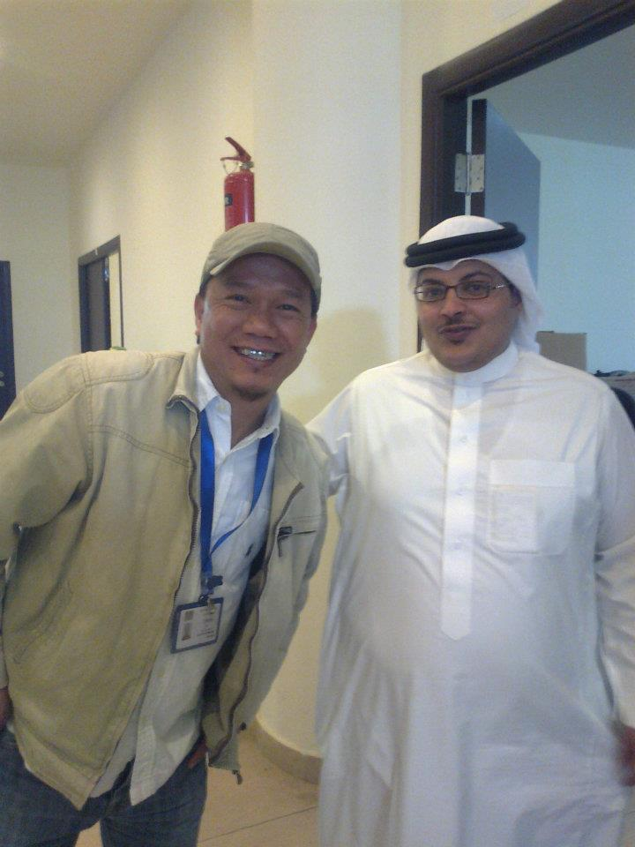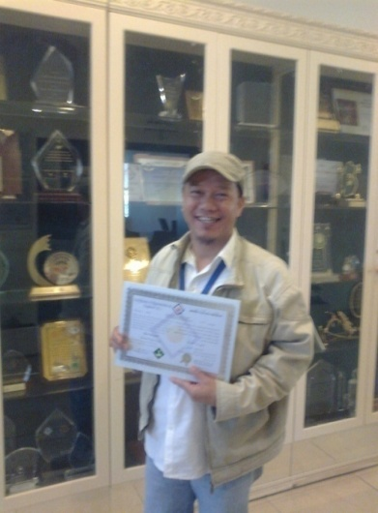

DAR AL RIYADH CONSULTANT TEAM – ITCC PROJECT
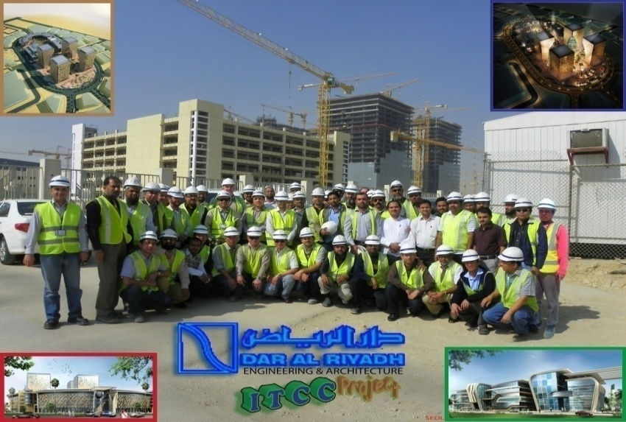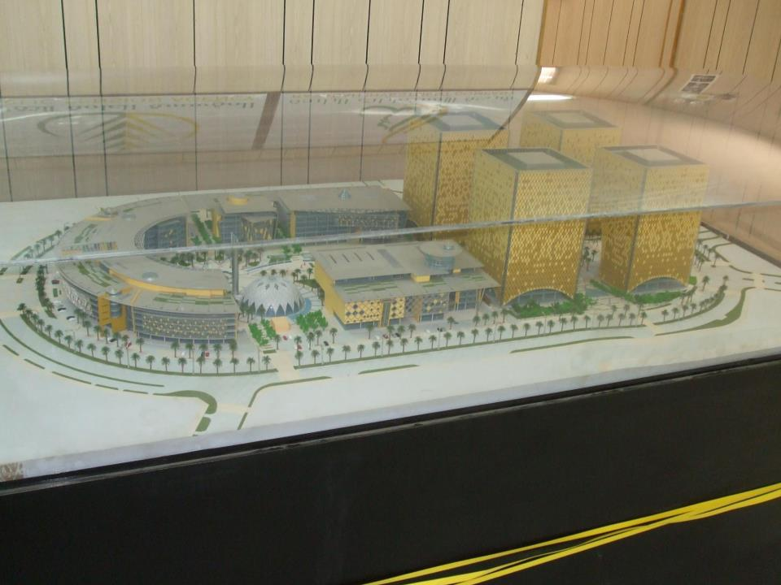

CERTIFICATES
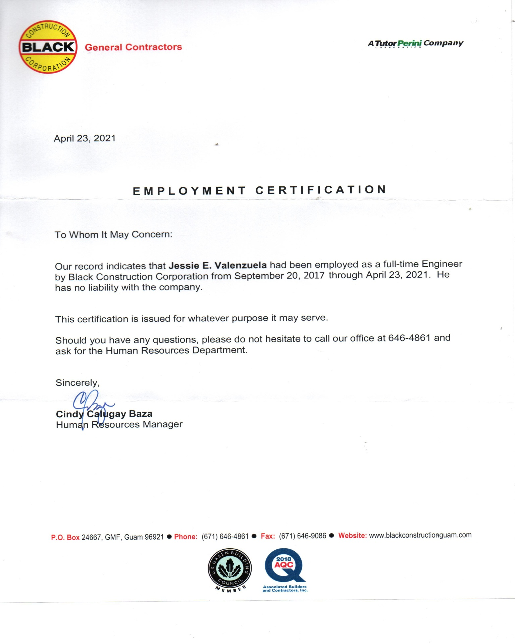

CERTIFICATES

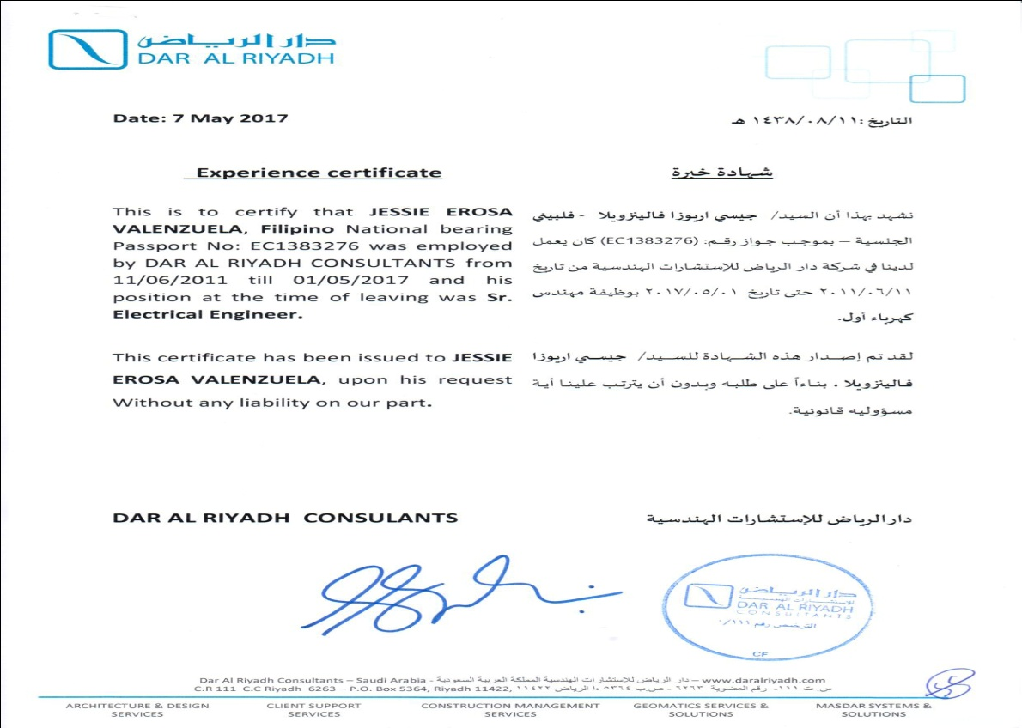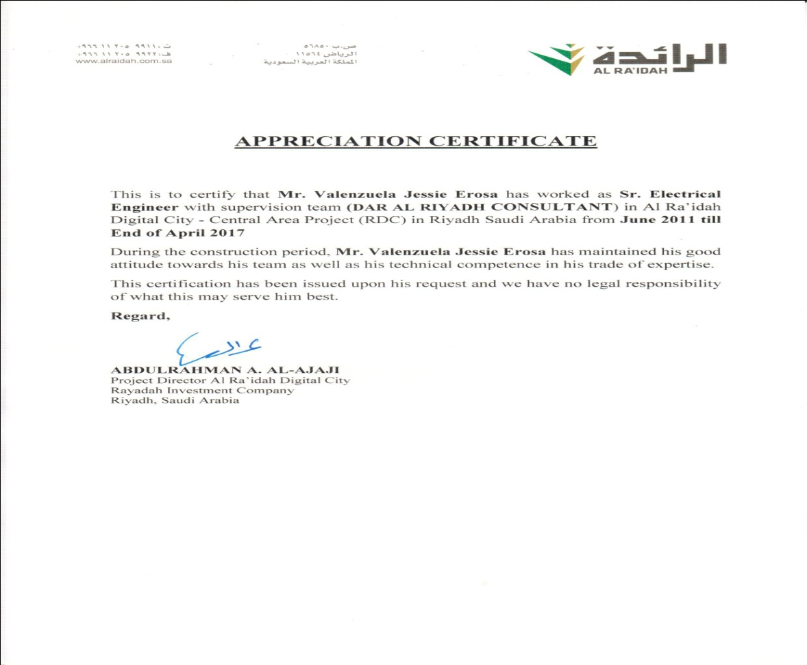

CERTIFICATES
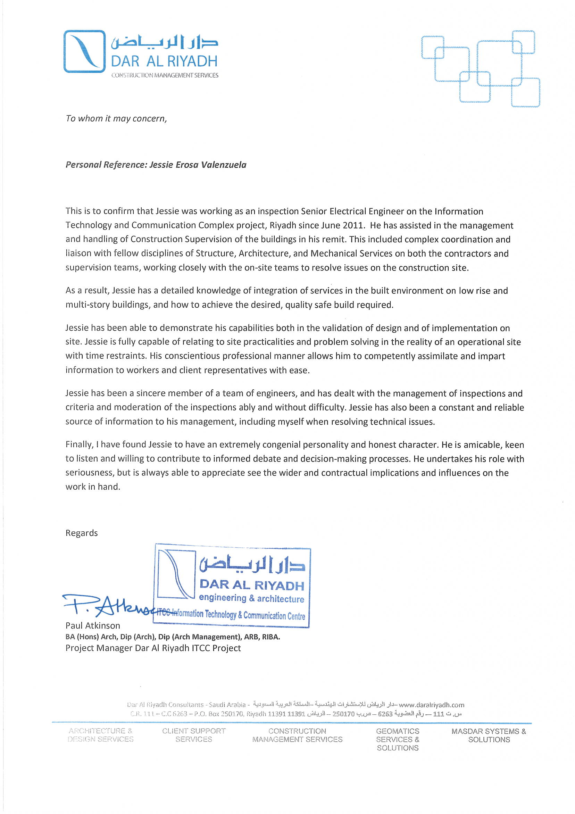

CERTIFICATES
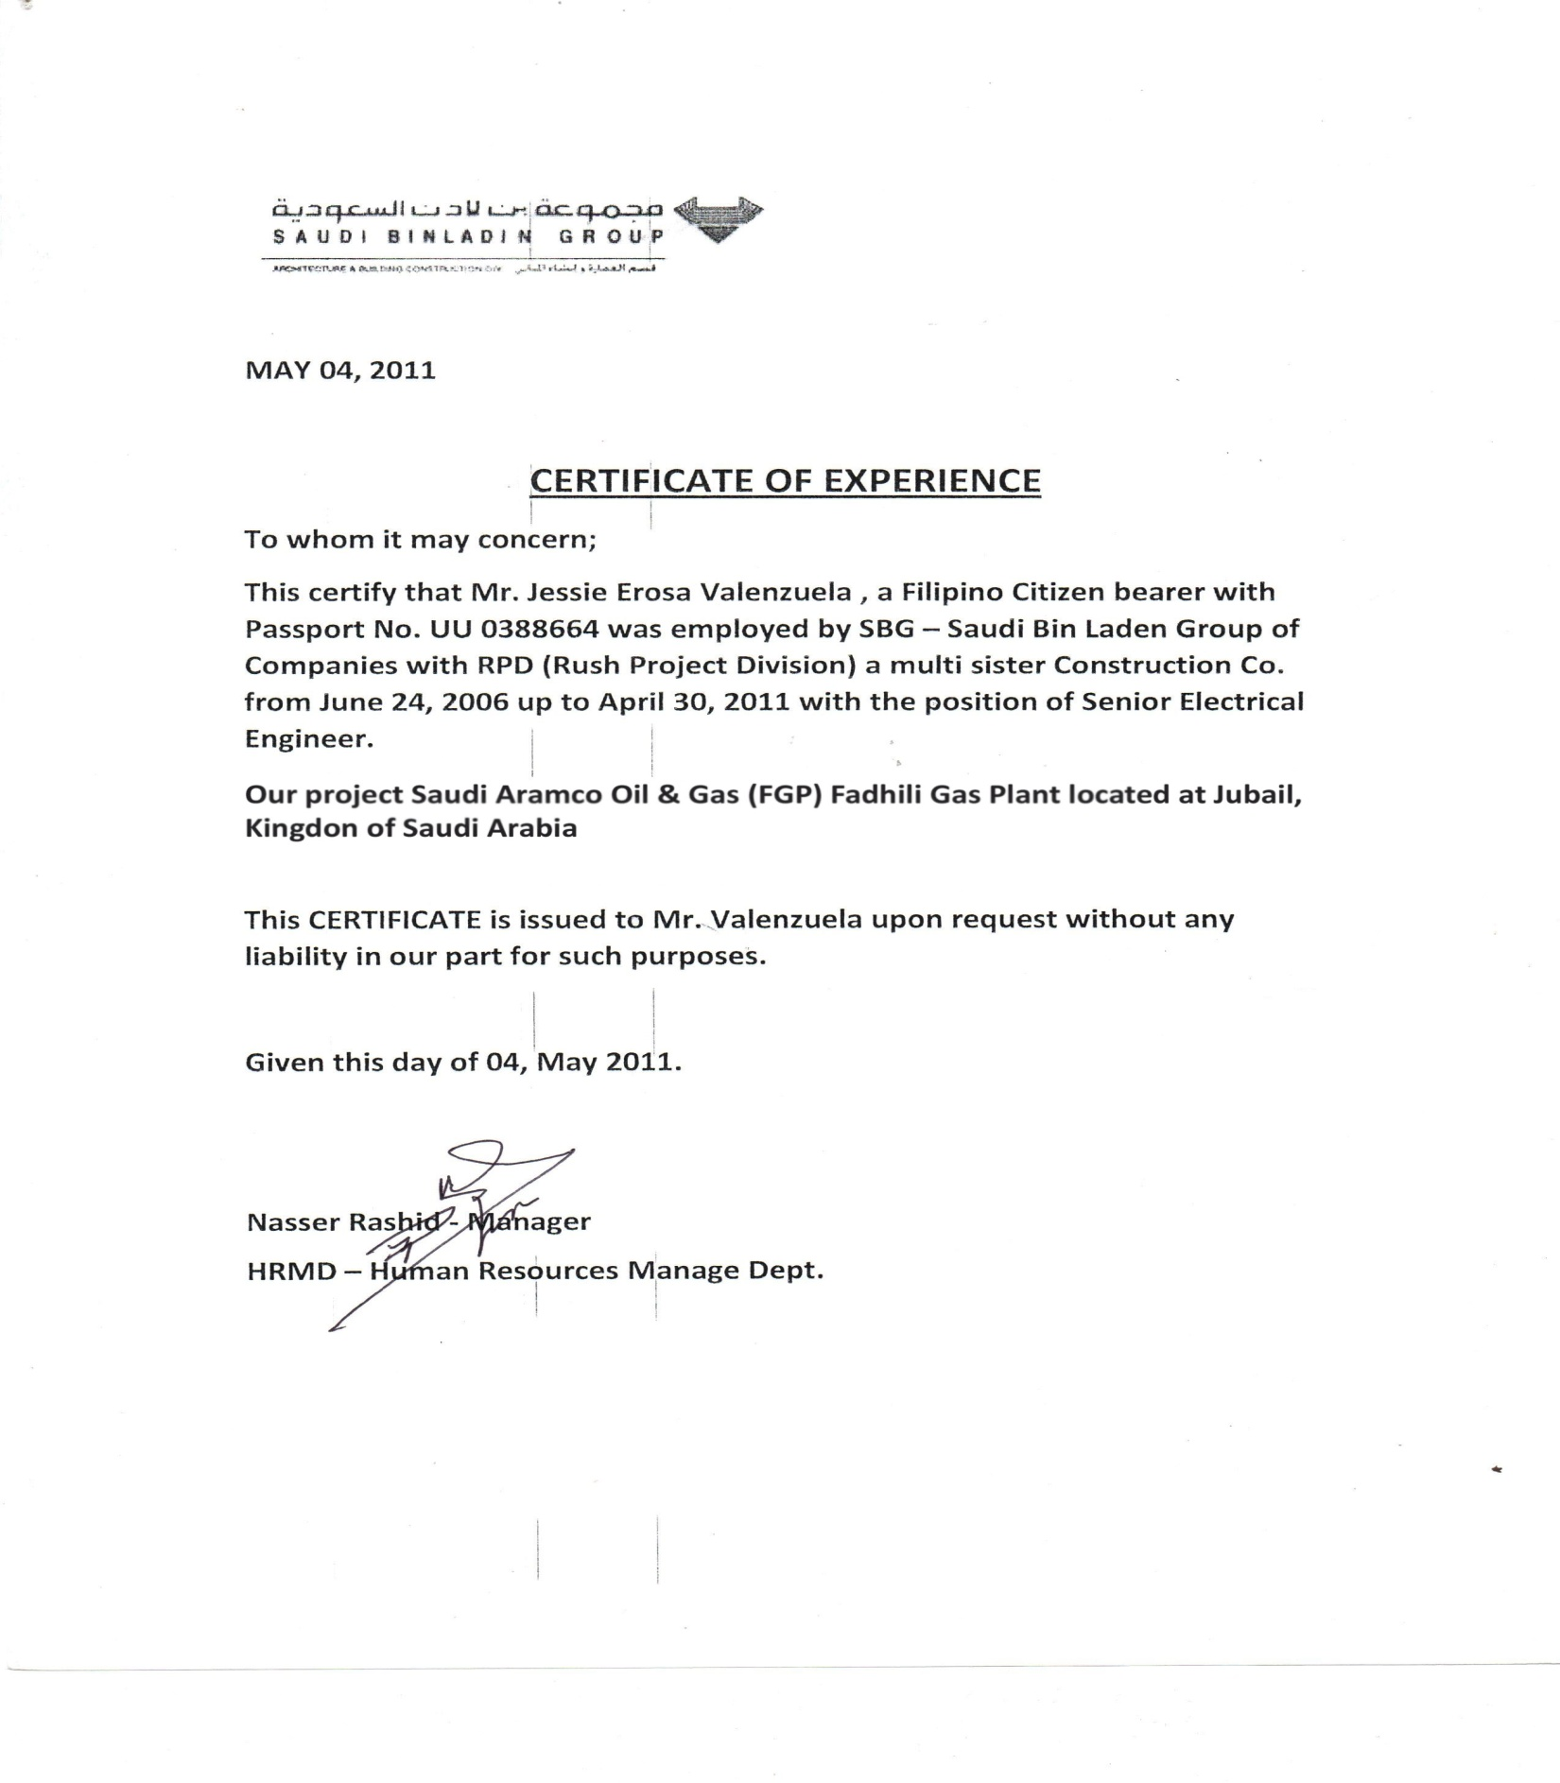

The 7th WORLDBEX Seminar
‘’ Exploring Advancement in Global Construction Network ‘’

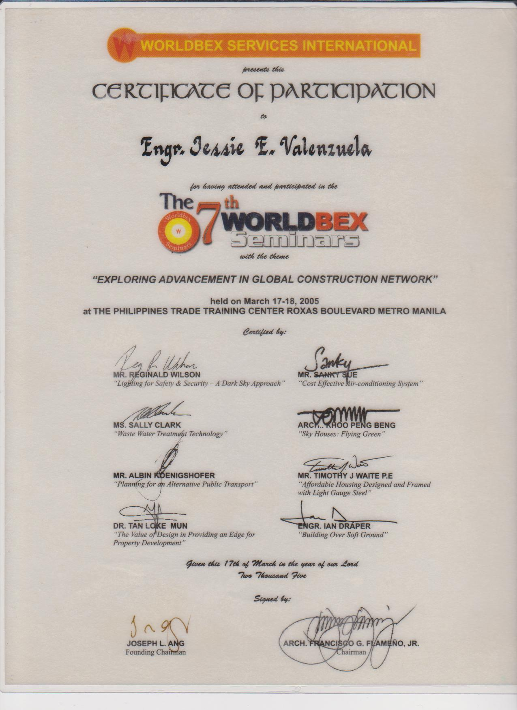

Basic Occupational Safety and Health Training
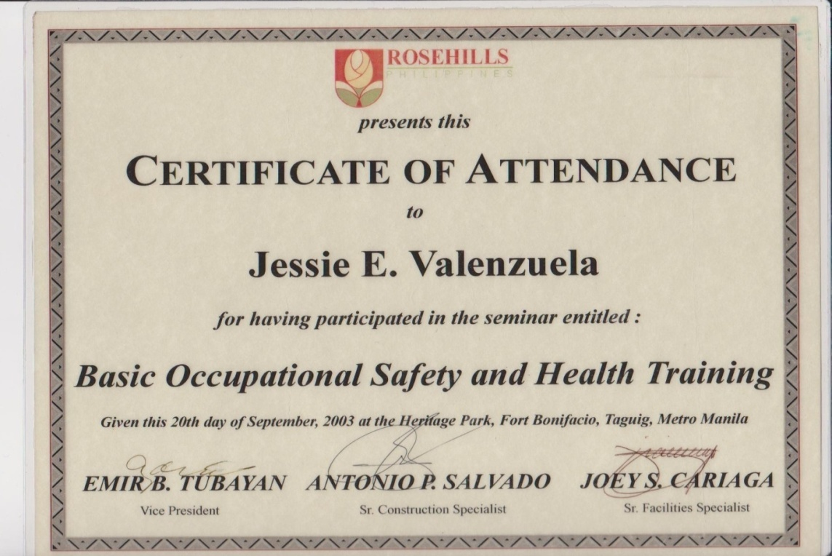

OSRAM Seminar Workshop & Product Orientation

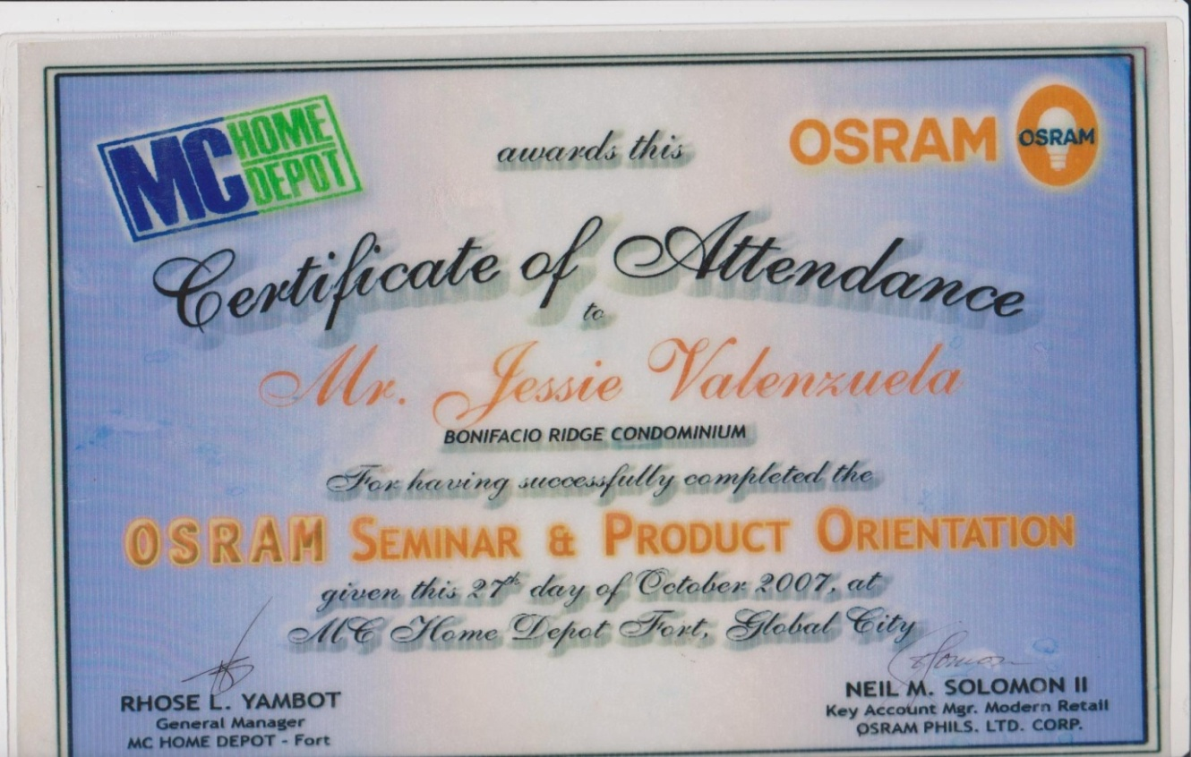

GMS INSTITUTE OF TECHNOLOGY

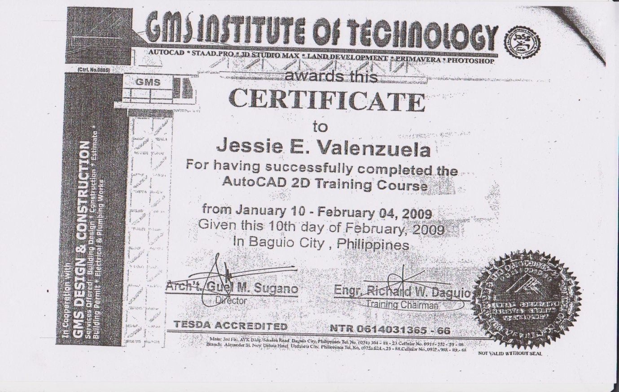

Company’s Work Certificates

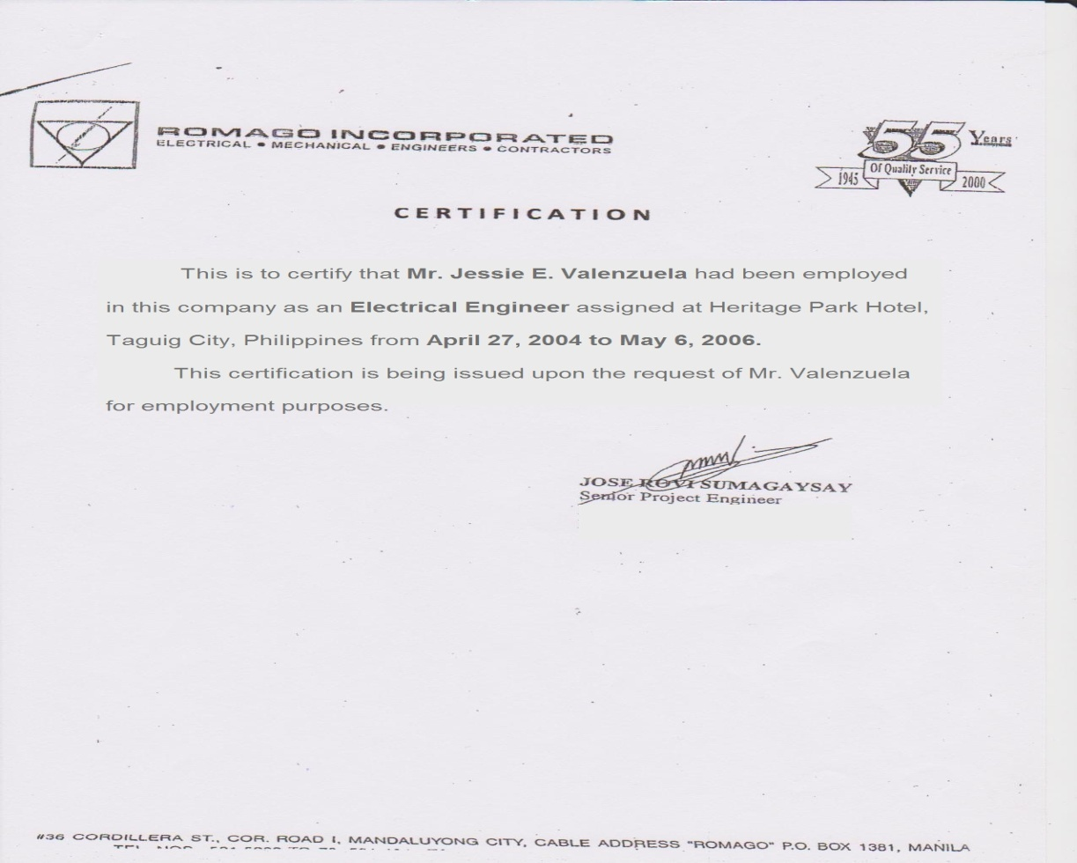

Company’s Work Certificates
