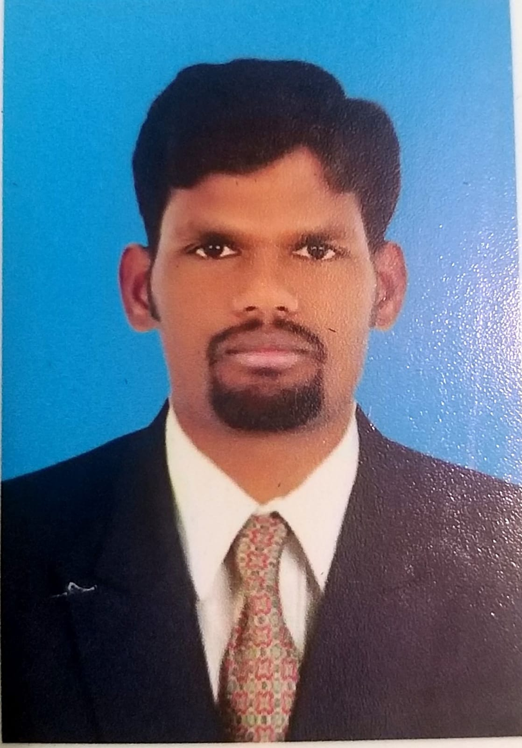
CURRICULUM VITAE
S. MANMOHAN
Instrumentation Engineer
Experience: 12 years
Email: manmohanshanmugam@gamil.com
linkedin.com/in/manmohan-shanmugam-40772b111
Mobil No. +96550435916
Objective:
Electrical & Instrumentation 12 years Extensive Experience Seeking managements position with an organization Where I can utilize my skills and experience to improve operations increase profitability and enhance growth.
Skill Set:
- Project Managements, Multitasking, critical thinking
- The ability to work well under pressure, the motivation to work extra hours when necessary
Professional Qualification:
- Engineering in Electrical and Electronics
Present Gulf Experience:
Liquefied natural gas, (LNG), Sulfur Recovery unit, (SRU) Tail Gas Treating unit, (TGTU) Acid Gas Flare Sulfur Storage Area, Sour Water stripper unit, (SWU) Amine Regeneration unit (AMU) Gas sweeting unit, (GSU) Gas Export unit, (GEU) Amine Regeneration unit (ARU) Liquefied petroleum gas (LPG), , Vender packages, HP, LP IA, compressor Fuel Gas Turbine Power Generation Station (GTG)33kv, 11kv Substation,
Project details:
Client : KUWAIT OIL COMPANY
Contractor : Petrofac
Position : Instrumentation Engineer
Duration : Sep-2021 to Till Date
Project details:
Client : KUWAIT INTEGRATED PETROLEUM INDUSTRIES
Contractor : FLUOR/HYUNDAI/DAEWOO E&C (FDH JV) Heisco
Position : Instrumentation Engineer
Duration : Jan 2019 to Sep 2021
Project details:
Client : GAZPROM NEFT Gas Plant
Contractor : SAMSUNG ENGINEERING Iraq. (Badra)
Position : Engineer
Duration : Jun 2015 to Nov 2018
Project details:
Client : ABUDHABI DISTRIBUTION COMPANY (ADDC)
Contractor : JUMA AL MAJID Abu Dhabi U.A.E
Position : Instrumentation Engineer
Duration : Nov 2009 to Dec 2014
Roles and Job responsibilities:
- Instrumentation Experience and Competent Engineer with excellent communication, organization, co-ordination operation team, HSES, PTW Ensure Area Classification And safety. work is done safely and efficiently control work is made up of permit to work hazard identification and risk assessment and isolation managements.
- Prepares project Documentation within one scope of deliverables and assists in preparing proposal/presentation of engineering projects / programs (provision of billing of materials estimated engineering hours etc.)
- Ability proper estimation (BOQ), Budget for the execution of projects
- Coordinates with Construction team All SAT activities and work priorities, study plans P&ID, PEFS, Schematic Logic single line wiring diagrams and drawings. Prepare materials, equipment’s and tools needed for the specific activities. Distribute manpower and monitor daily accomplishment for daily activity report.
- Conducted and coordinated with various departments and performed Factory and Site Acceptance Tests.
- Trained team members on need of client, contract obligations and commissioning activity that were required to be followed.
- Provided necessary support for commissioning activities in operational phase of project.
- Evaluated contractor and vendor documentation and ensured that test procedures were carried in accordance to same
- Provide regular feedback to the Manager/Operation Superintendent on progress, achievements, safety and quality related issues Approves completed work orders and stores requisitions for materials
- Observes work in progress to ensure that procedures are followed and materials used conform to specifications
- Witnessing and approving Managements /pre-commissioning activities such as pressure testing, flushing/blowing and reinstatement
- PPM more commonly referred to as simply Planned preventive maintenance scheduled it is a proactive approach to maintenance in which maintenance work is scheduled to take place regularly and consequently documented once it has taken place
Core Qualifications
- Leading a team in erecting of Instrument installation, Calibration, stanchion installation, conduit laying local control panel installation, JB frame and JB installation, Cable laying, gladding, Honeywell ABB, yokogawa Transmitters Loop checking and commissioning activities in accordance with AFC Drawings.
- Servicing and calibration of electronic and pneumatic pressure measuring instruments like Foundation Fieldbus SMART pressure transmitter, pressure switches, Level Transmitters Flow Transmitters, Flow Transmitters, Temperature Transmitters, Valve Positioners, and Control Valves, PSD & ESD Valves. Instrumentation testing kits.
- Hands on experience Calibration Activities, Cable Testing, Pressure/Leak Testing, Hot, Cold, IRP Motor Loops. Maintenance, trouble shooting and rectification of various field instrumentation system like, PT/LT/FT/TT/CV/PSD/ESD/EDP/FCV/HV/LV System,
- To supervise all Instrument Maintenance pre-commissioning, commissioning and start-up activities for assigned sub-systems. This includes preparatory activities, coordinating resources (technicians, equipment, other departments), expediting documentation – in particular handover dossiers, attending walk-downs from construction and categorizing punch-list items.
- Maintenance, trouble shooting of F & G Instruments like Flammable Gas Detectors, Hydrogen Gas detector, Oxygen Deficiency Detector, Toxic Gas Detector, CO2 Gas Detector, Rate of Rise Heat Detector, Smoke Detector, High Sensitivity Smoke Detector, Aspirator HVAC Duct Probe, Visual Alarm Beacon

Personal Details:
Name : MANMOHAN SHANMUGAM
DOB : 20-June-1986
Nationality : Indian
Permanent Address : Kuwait Fahaheel
Mobile No : +96550435916
Passport No. : R4768612
Expire on : 20/06/2027
Place of Issue : Chennai
Language : Tamil English Hindi

I hereby declare that the information give above is true and correct to the best of my Knowledge

Place: Kuwait
Date: MANMOHAN SHANMUGHAN

