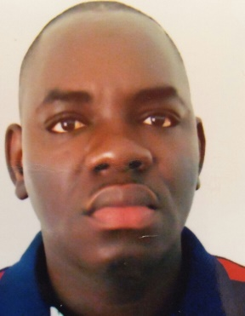
SKILLS
- PLC Programming
- Electrical Troubleshooting
- Maintenance management
- Manages a 66 MW power plant gas engines with a team of 36 electricians and mechanicians

- Fluent French
- Intermediate English

PROFESSIONAL EXPERIENCES
- January 28, 2003, to April 29, 2003: Internship at the Industrial Company of plastic of Senegal as an electrician.
- 02 November 2004 to 30 September 2005: Employee at Sahel Cements Industry as an automatic technician.
- October 06, 2005, to March 1st, 2007: Employee at the West African Tobacco Factory (Imperial tobacco) as an electrical technician
- March 05, 2007, to March 1, 2015: electrical technician at PHILIP MORRIS Manufacturing Senegal.
- March 01, 2015, to May 1, 2018: Maintenance supervisor at PHILIP MORRIS Manufacturing Senegal.
- May 01, 2018, to May 26, 2020: Electrical engineer at PHILIP MORRIS Manufacturing Senegal.
- Current position: Head of electrical department at GREENVILLE OIL & GAZ Nigeria

Electromechanical engineer
With 18 years of experience currently head of electrical department in GREENVILLE OIL& GAZ
Ibrahima KANE
46 years old
Dakar-Senegal
Call : +221775184663/ +2347056906607
Wathaps : +221775184663
Mail : kaneiibou@hotmail.com

COMPANY TRAINING
- 2005: One week training with HAUNI on KDF-2ER machines
- 2007: Advanced training course in STEP 5 and Micro masters controllers with the Siemens training center of Switzerland.
- 2008: training course with LNI on PM2 / PM3 and MIDAS
- 2007: Three-week advanced training course on OMRON PLC with Senegal / Japan vocational and technical center.
- 2011: One-week electrical training course in France on troubleshooting with DECOUFLE training center.
- 2011: three-week training course in Philip Morris RUSSIA on BECKHOFF PLC.
- 2013: Two-week training course with Philip Morris Poland on BECKHOFF PLC.
- 2015-2018: several seminars in team management and maintenance management.

STUDIES
- 1997: Scientific Baccalaureate at Lamine Gueye School.
- 1999: university degree in scientific studies in physics and chemistry
- 2002: Certificate of higher technician in automatic at the CFPT (vocational and technical center Senegal / Japan)
- 2014: Bachelor's degree in electromechanical engineering at the polytechnic higher school of Dakar.
- 2015: Master 1 in electromechanical engineering at the polytechnic higher school of Dakar.
- 2016: Master 2 in electromechanical engineering at the polytechnic higher school of Dakar.

